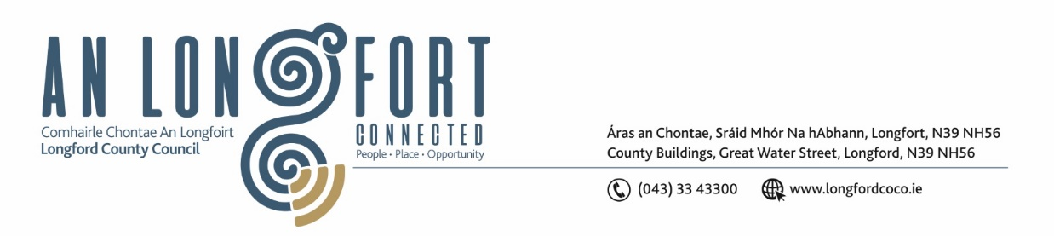

**BALLYMAHON MUNICIPAL DISTRICT**

**Minutes of Meeting of Ballymahon Municipal District**

**held in Ballymahon Library**

**on Thursday 22 February 2024 at 4pm**

**­­­­­­­­­­­­­­­­­­­­­­­­__________________________________________________________________________**

**CATHAOIRLEACH**: Councillor Paul Ross

**MEMBERS PRESENT**: Councillors – Pat O’Toole, Colm Murray

Mick Cahill, Gerard Farrell, Mark Casey

**IN ATTENDANCE:**  Ms. Samantha Healy, Director of Service

Mr. Brian Mc Neela, A/Senior Executive Engineer

Mr. Darren Lennon, Technician

Ms. Claire McDermott, Administrative Office

Ms. Ruth Jordan

**APOLOGIES:** Ms. Claire McNabola

**A/MEETINGS ADMINISTRATOR**: Ms. Claire McDermott

1. **ADOPTION OF MINUTES**
2. On the proposal of Councillor Mick Cahill seconded by Councillor Pat O’Toole the Minutes of Ballymahon Municipal District Meeting held on the 7 December 2023, as circulated, were confirmed and adopted.
3. **MATTERS ARISING**

None

1. **DECLARATION OF INTEREST BY MEMBERS**

Councillor Colm Murray declared interest in Pillar Box Drama Group

Councillor Pat O’Toole declared interest in Ballymahon St. Patrick’s Day Parade Committee and Ballymahon Community Employment.

1. **MANAGEMENT REPORT - as circulated**

The members noted the Management report, proposed by Councillor Mick Cahill, seconded by Councillor Colm Murray

1. **TOWN TWINNING REPORT**

Noted

1. **COMMUNITY GRANT SUPPORT SCHEME 2024**

Grant applications were reviewed, and funding allocated. List of approved bodies and amounts attached.

Members requested CGSS 2024 be on the agenda for the Committee meeting on 28 March 2024 as seeking clarification on some applications.

Proposed transfer of funding from Special Projects allocation of €12,000 to:

Arts Activities €5,125

Tidy Towns €100

Proposed by Councillor Colm Murray, seconded by Councillor Pat O’Toole

1. **CONSIDERATION OF DRAFT MUNICIPAL DISTRICT REPORT FOR INCLUSION IN LONGFORD COUNTY COUNCIL 2023 ANNUAL REPORT**

On the proposal of Councillor Pat O’Toole and seconded by Councillor Colm Murray the members approved submission for inclusion in the Longford County Council 2023 Annual Report

1. **NOTICE OF MOTIONS, AS SUBMITTED BY COUNCILLORS**

**The following notice of motion was proposed by Councillor Paul Ross and seconded by Councillor Colm Murray**

1. That Longford County Council apply for a low-cost safety scheme at the townland of Aghintemple/Killenastra, Ardagh on the R393 to install a crash barrier on the dangerous bend where there have been many crashes including a crash in which a vehicle hit a house and burned it down.

**Response:**

Longford County Council will consider the appropriate measures for this location and will consider this location for future low cost safety scheme applications.

**The following notice of motion was proposed by Councillor Paul Ross and seconded by Councillor Pat O’Toole**

1. That Longford Co Council in conjunction with The OPW reinstate the timber post and rail fence at the Royal Canal, Terlicken, Ballymahon as the existing fence has blown down.

**Response**

Brian McNeela has contacted Waterways Ireland and they have given a commitment to reinstate the timber post and rail fence.

**The following notice of motion was proposed by Councillor Paul Ross and seconded by Councillor Gerard Farrell**

1. That a pedestrian crossing be installed at junction of The Park House Hotel and Kilbride Park in the interest of public safety.

**Response**

The roads section will assess this location for traffic calming measures and measures to improve pedestrian safety and will consider this location for low cost safety funding in 2025.

**The following notice of motion was proposed by Councillor Pat O’Toole and seconded by Councillor Colm Murray**

1. I call on Longford County Council to upgrade the lighting over the pedestrian crossing at St. Matthew’s Church Ballymahon similar to what is provided at the pedestrian crossing at St.Matthew’s Primary School.

**Response**

Longford County Council will review lighting levels at the pedestrian crossing at St Matthews Church and will carry out any upgrade works necessary on foot of that review.

**The following notice of motion was proposed by Councillor Pat O’Toole and seconded by Councillor Mick Cahill**

1. I call on Longford County Council to carry out an assessment of St.Anne’s Housing Estate off Main Street Ballymahon (6 houses) with a view to carrying out a deep retrofit of same.

**Response**

Longford County Council will carry out an assessment of St. Annes Housing Estate and will consider these houses as part of the Energy Efficiency Retrofit Programme

This concluded the business of the meeting.

**Signed:_____________________**

**Claire McDermott**

**Ballymahon MD Administrator**

**Confirmed and adopted at Ballymahon Municipal District Meeting held on the 28 March 2024.**

**Signed: _______________**

**Cathaoirleach**